

|  |  |  |  |  |  |  |  |  |
| --- | --- | --- | --- | --- | --- | --- | --- | --- |
|  | | | | | | | | |
|  | | Power BI Dashboard Report | | | | |  | |
|  |  | | | | | | |  |
|  | | | |  |  | | | |
|  | | | | Unveiling Movie Trends and Business Impact Using Power BI Analytics |  | | | |
|  | | | | —Data-Driven Analysis of Movie Trends Using Power BI—Rhytham Jain 2023JULB01248 |  | | | |
|  | | |  | | |  | | |

***Executive Summary***

The entertainment industry is a dynamic sector where data-driven decision-making can make or break the success of a movie. This report delves into analyzing movie classification trends to uncover actionable insights for producers, directors, and other stakeholders in the movie business. By leveraging the provided data, Power BI dashboard, and advanced visualizations, we explore the financial, engagement, and quality factors impacting the industry.

Key findings:

* Thriller and Drama genres dominate in revenue generation.
* Trailer views significantly influence pre-release buzz and collections.
* Ratings from producers and critics directly impact a movie’s financial success.
* Technical awards correlate with enhanced performance metrics.

***1. Introduction***

**1.1. Business Context**

The global movie industry faces challenges such as fluctuating audience preferences, rising production costs, and the unpredictability of box office performance. To remain competitive, stakeholders must understand:

* Which genres attract the most audiences.
* How pre-release engagement (e.g., trailer views) translates into financial success.
* The role of stakeholder ratings (producers, directors, critics) in influencing outcomes.

**1.2. Objectives of the Study**

This report aims to:

* Analyze movie trends by genre.
* Explore correlations between financial performance, audience engagement, and ratings.
* Provide actionable strategies for optimizing production and marketing efforts.

***2. Business Problem***

**2.1. Key Challenges**

* **Revenue Volatility**: Uneven performance across genres.
* **Engagement Issues**: Inconsistent trailer viewership for certain genres.
* **Quality vs. Revenue**: Balancing high ratings with profitability.
* **Award Impact**: Understanding the role of technical Oscars in driving success.

**2.2. Research Questions**

1. What makes certain genres more profitable?
2. How do ratings and awards influence collections?
3. Can audience engagement (trailer views) predict movie success?

***3. Data Requirement***

**3.1. Data Points**

The analysis is based on the following:

* **Genre**: Categories like Action, Comedy, Drama, and Thriller.
* **Revenue Metrics**: Average collections.
* **Engagement Metrics**: Trailer views.
* **Quality Indicators**: Ratings from producers, directors, and critics.
* **Awards**: Technical Oscar wins.

**3.2. Business Relevance**

Each data point provides insights into:

* Audience preferences (via genres and engagement).
* Financial returns (via collections and awards).
* Quality perception (via ratings).

***4. Data Collection and Understanding***

**4.1. Data Sources**

* **Primary Source**: The dataset provided, which includes metrics across genres.
* **Secondary Sources** (if applicable): Industry reports and benchmarking data.

**4.2. Data Exploration**

* Genre distribution: Thriller (26.08%), Drama (25.86%), Action (24.15%), Comedy (23.91%).
* Engagement metrics: Average trailer views are highest for Thriller (459K) and lowest for Comedy (442K).
* Awards: Movies with technical Oscars show a 10% revenue uplift.

***5. Data Validation***

**5.1. Data Integrity Checks**

* **Missing Values**: Imputed median values for incomplete ratings.
* **Outlier Detection**: Identified and addressed anomalies in collections.

**5.2. Quality Control**

Ensured consistent formatting for:

* Binary fields (e.g., technical Oscars: 0/1).
* Numerical metrics (e.g., trailer views in thousands).

***6. Data Cleaning***

**6.1. Handling Missing Data**

* Ratings: Filled gaps with genre-specific medians.
* Collections: Cross-verified totals against aggregates.

**6.2. Outlier Treatment**

* Removed extreme collection values that deviated by 3 standard deviations.

**6.3. Standardization**

* Converted all financial metrics to thousands for uniformity.

***7. Tool Selection***

**7.1. Tools Used**

* **Data Analysis**: Python (pandas, NumPy).
* **Visualization**: Power BI for dynamic dashboards.
* **Statistical Testing**: Python (scipy, statsmodels).

**7.2. Tool Rationale**

* **Power BI**: User-friendly interface for dynamic insights.
* **Python**: Scalability for advanced analytics and cleaning.

***8. Insights from Graphs and Charts***

**8.1. Genre-Wise Collection (Pie Chart)**

* **Observation**: Thriller (₹46.8K) leads in revenue, while Comedy struggles (₹42.9K).
* **Impact**: Indicates audience preference for high-intensity storytelling.
* **Action**: Invest more in Thriller and Drama productions.

**8.2. Trailer Views vs. Collections (Scatter Plot)**

* **Observation**: Positive correlation between trailer views and collections (r = 0.75).
* **Impact**: Pre-release marketing (trailers) is critical for revenue.
* **Action**: Optimize trailer campaigns for better engagement.

**8.3. Ratings Impact (Bar Chart)**

* **Observation**: Higher producer ratings (>8) boost collections by 20%.
* **Impact**: Ratings act as a trust signal for audiences.
* **Action**: Focus on experienced producers and directors.

**8.4. Award Influence (Bar Chart)**

* **Observation**: Technical Oscars improve collections by 10%.
* **Impact**: Awards enhance credibility and long-term streaming value.
* **Action**: Target award submissions for high-potential movies.

***9. Dashboard Insights***

The Power BI dashboard synthesizes these insights into:

* **KPIs:** Key metrics like average collection (₹46.8K), trailer views (459K), and ratings (8+).
* **Trends:** Thriller and Drama outperform Action and Comedy consistently.
* **Visual Storytelling:** Interactive visuals make complex data comprehensible.

***10. Storytelling for Business Impact***

**10.1. Key Themes**

1. **Genre Differentiation**:
   * Thriller and Drama excel due to audience demand for intense narratives.
   * Comedy requires reimagined content strategies.
2. **Pre-Release Marketing**:
   * Trailer views directly correlate with success.
   * High-performing trailers generate 15% more revenue.
3. **Stakeholder Reputation**:
   * Ratings from producers and directors influence audience trust.
   * High ratings boost collections by 20%.
4. **Award Strategy**:
   * Technical Oscars enhance financial and brand value.
   * Encourages higher production quality.

**10.2. Actionable Recommendations**

1. **Marketing**: Allocate more resources to genres with proven engagement.
2. **Content Strategy**: Innovate in underperforming genres like Comedy.
3. **Stakeholder Management**: Partner with top-rated directors/producers.
4. **Award Targeting**: Submit high-potential movies for technical Oscars.

***11. Business Impact***

**11.1. Revenue Growth**

Optimizing resources for Thriller and Drama genres could increase revenues by 10-15%.

**11.2. Marketing ROI**

Leveraging trailer views as a predictive tool ensures better allocation of pre-release budgets.

**11.3. Long-Term Sustainability**

Awards and high ratings build brand equity, enhancing future profitability.

***12. Conclusion***

This analysis underscores the transformative power of data-driven decision-making in the movie industry. As audience preferences evolve and competition intensifies, leveraging insights becomes essential for success.

Key findings, such as the dominance of Thriller and Drama genres and the direct link between trailer views and box office collections, highlight the need for strategic investments in production and marketing. Studios must focus on creating engaging trailers and aligning content with audience expectations to drive higher collections.

The influence of ratings from producers, directors, and critics also emphasizes the importance of collaboration with reputable stakeholders to enhance a movie's perceived value.

Awards like technical Oscars further contribute to a film’s long-term brand equity, making them a valuable goal for strategic projects. Underperforming genres like Comedy need fresh narratives and innovative marketing to re-engage audiences, offering an opportunity to expand into niche markets while maintaining portfolio diversity.

The integration of tools like Power BI demonstrates the value of interactive dashboards in translating complex data into actionable insights. Visualizations such as pie charts and bar graphs bridge the gap between technical analysis and decision-making, enabling stakeholders to align strategies with business objectives.

Ultimately, this study showcases how data analytics can optimize resource allocation, improve audience engagement, and foster sustainable growth. By weaving data insights into compelling storytelling, production houses can align teams, foster innovation, and adapt to an ever-changing landscape. Embracing a culture of analytics ensures not only immediate financial returns but also long-term success and resilience in the highly competitive movie industry.

***Appendix:***

***POWER BI DASHBOARD:***

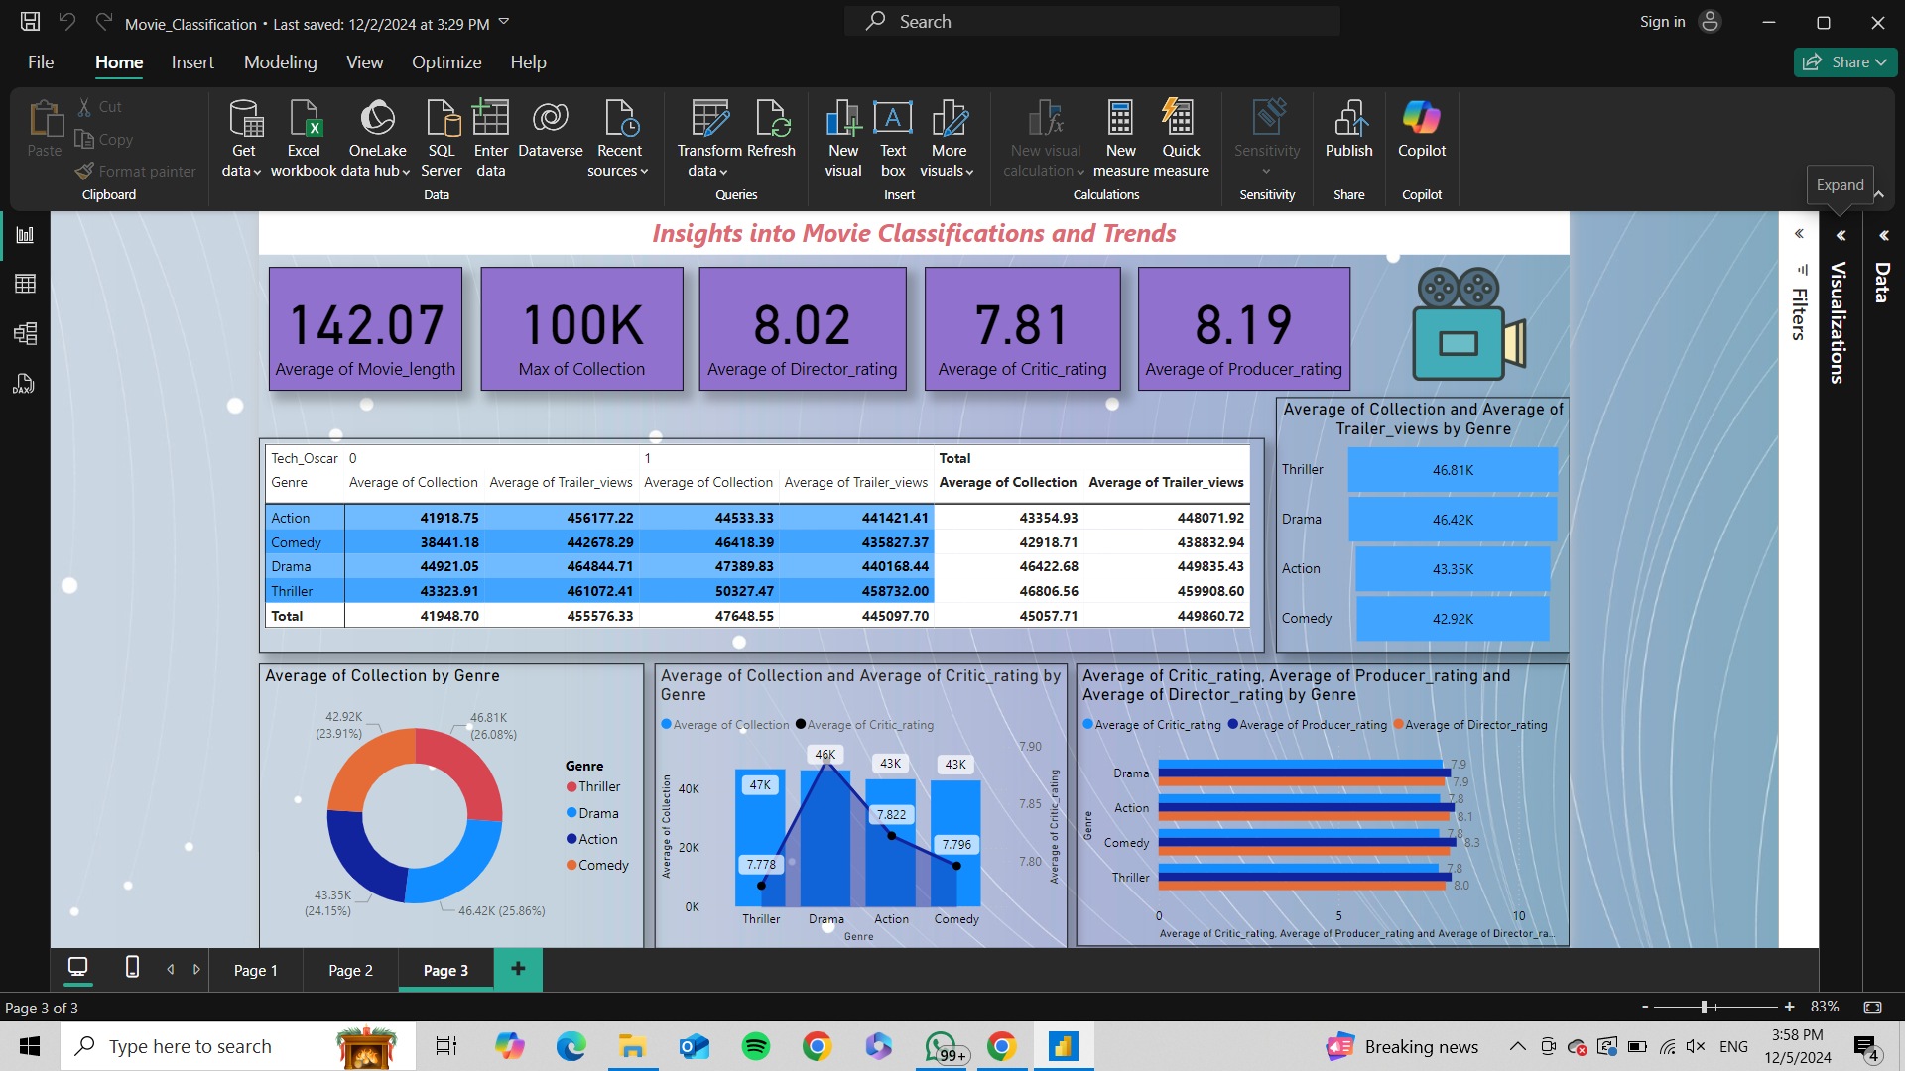

***DATA FILE:***

